Microsoft Azure - Starter Kits for Partners

Hands on Lab

Mobile App with Xamarin and Azure

Last Update: September 2016





**MICROSOFT MAKES NO WARRANTIES, EXPRESS, IMPLIED OR STATUTORY, AS TO THE INFORMATION IN THIS DOCUMENT.**

The information contained in this document represents the current view of Microsoft Corporation on the issues discussed as of the date of publication. Because Microsoft must respond to changing market conditions, it should not be interpreted to be a commitment on the part of Microsoft, and Microsoft cannot guarantee the accuracy of any information presented after the date of publication.

Complying with all applicable copyright laws is the responsibility of the user. Without limiting the rights under copyright, no part of this document may be reproduced, stored in or introduced into a retrieval system, or transmitted in any form or by any means (electronic, mechanical, photocopying, recording, or otherwise), or for any purpose, without the express written permission of Microsoft Corporation.

Microsoft may have patents, patent applications, trademarks, copyrights, or other intellectual property rights covering subject matter in this document. Except as expressly provided in any written license agreement from Microsoft, the furnishing of this document does not give you any license to these patents, trademarks, copyrights, or other intellectual property.

The descriptions of other companies’ products in this document, if any, are provided only as a convenience to you. Any such references should not be considered an endorsement or support by Microsoft. Microsoft cannot guarantee their accuracy, and the products may change over time. Also, the descriptions are intended as brief highlights to aid understanding, rather than as thorough coverage. For authoritative descriptions of these products, please consult their respective manufacturers.

© 2015 Microsoft Corporation. All rights reserved. Any use or distribution of these materials without express authorization of Microsoft Corp. is strictly prohibited.

Microsoft and Windows are either registered trademarks of Microsoft Corporation in the United States and/or other countries.

The names of actual companies and products mentioned herein may be the trademarks of their respective owners.

Contents

Introduction 4

Azure Services Overview 4

Tutorials for Implementing the Mobile Application & Back end 5

Shopping Demo App Overview 5

Deploy to your subscription. 5

Authenticate and authorize users with Twitter and Facebook 5

Allow your app to work offline and sync after 5

Send and receive push notifications on iOS, Android, and Windows 5

Store your app data in the cloud 5

Use Microsoft Cognitive Services to personalize your app’s responses 5

# Introduction

This document is designed to assist the consultant responsible for delivering this solution and acts a reference for the online documentation about how to leverage **Azure capabilities** to build the back end for a Cross Platform Mobile Application.

# Azure Services Overview

Azure Mobile Services quickly adds login, push, and data sync to your iOS, Android, or Windows app. Connect your app to enterprise systems and on-premises resources. Scale your app to millions of customers across multiple geographies:

* Secure and store data in the cloud from your mobile app on any device
* Deliver a global mobile app with high availability and low latency
* Engage your customers with push notifications
* Expand your web presence with mobile apps
* Build your mobile app to enterprise line-of-business systems

**Azure App Service** is a new and unique cloud service that enables developers to create web and mobile apps for any platform and any device. App Service is an integrated solution designed to streamline repeated coding functions, integrate with enterprise and SaaS systems, and automate business processes while meeting your needs for security, reliability, and scalability.

App Service brings together the following existing Azure services - Websites, Mobile Services, and BizTalk Services into a single combined service, while adding powerful new capabilities. App Service allows you to host the following app types:

• Web Apps

• Mobile Apps - Mobile Services continue to be available as a standalone service and remain fully supported.

• API Apps

• Logic Apps

# Tutorials for Implementing the Mobile Application & Back end

## Shopping Demo App Overview

Learn how to connect your Xamarin mobile apps to the cloud. The Shopping Demo App is a great business-to-consumer application sample available on multiple platforms. This mobile app demo uses a wide range of Azure services to help users authenticate with Facebook or Twitter, sell and buy personal items, get notifications when items are purchased, and rate the app with a smile. Play with the app code in our GitHub repo, find documentation that shows you how to connect your apps to the cloud, and deploy it to your own Azure subscription now.

### [Deploy to your subscription](https://github.com/Microsoft/XamarinAzure_ShoppingDemoApp/tree/master/Xamarin.Azure.Backend.Deployment).

|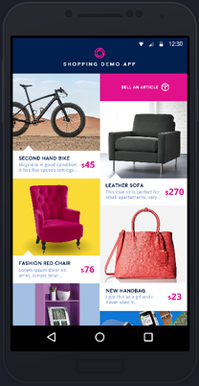 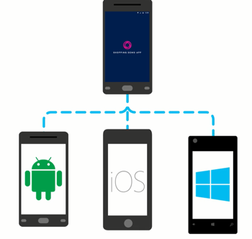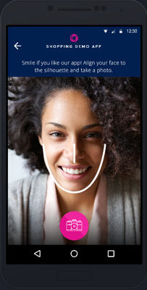

App Service is a platform-as-a-service (PaaS) offering of Microsoft Azure. It allows to create mobile apps for any platform or device. You can integrate your apps with several SaaS solutions as Authentication, Push Notifications, Storage, etc.

The following tutorials explain how to work with App Service and show you quickly and easily use several App Service features based on the Shopping Demo App available on GitHub

### [Authenticate and authorize users with Twitter and Facebook](https://github.com/Microsoft/XamarinAzure_ShoppingDemoApp/wiki/Authentication-Authorization)

### [Allow your app to work offline and sync after](https://github.com/Microsoft/XamarinAzure_ShoppingDemoApp/wiki/Offline-Data-Sync)

### [Send and receive push notifications on iOS, Android, and Windows](https://github.com/Microsoft/XamarinAzure_ShoppingDemoApp/wiki/Push-Notifications)

### [Store your app data in the cloud](https://github.com/Microsoft/XamarinAzure_ShoppingDemoApp/wiki/Storage)

### [Use Microsoft Cognitive Services to personalize your app’s responses](https://github.com/Microsoft/XamarinAzure_ShoppingDemoApp/wiki/Cognitive-Services)